Task 3

Resources:

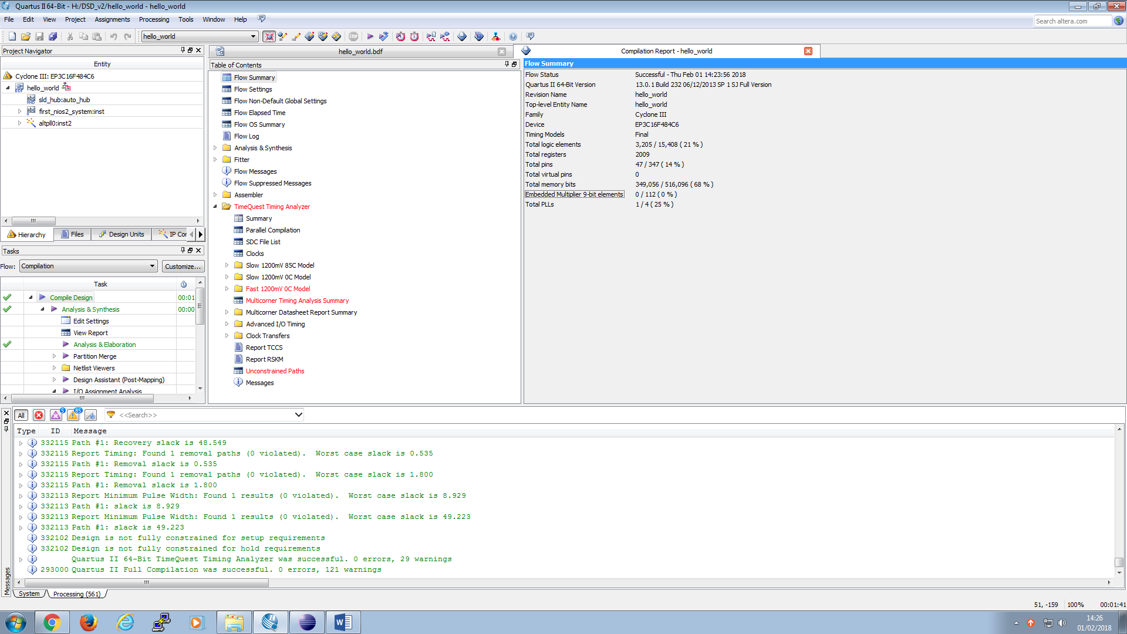

Timing analysis:

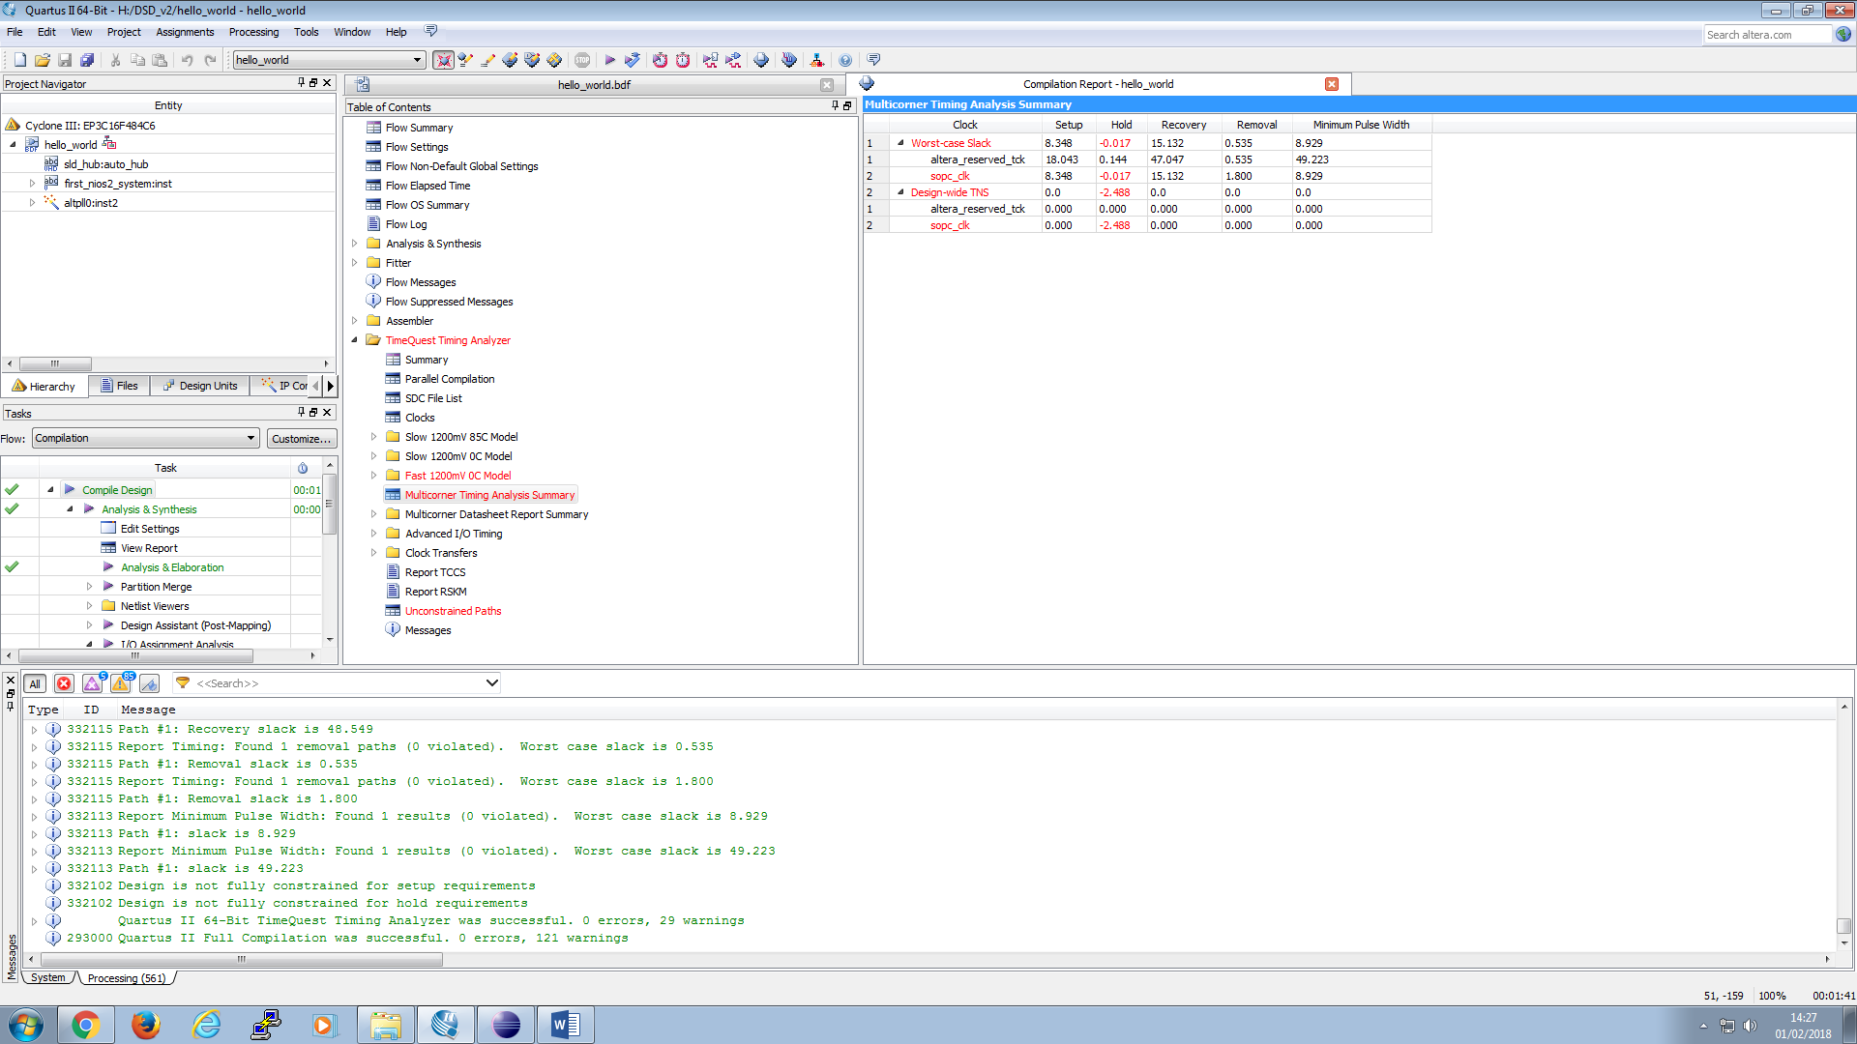

Able to do count:

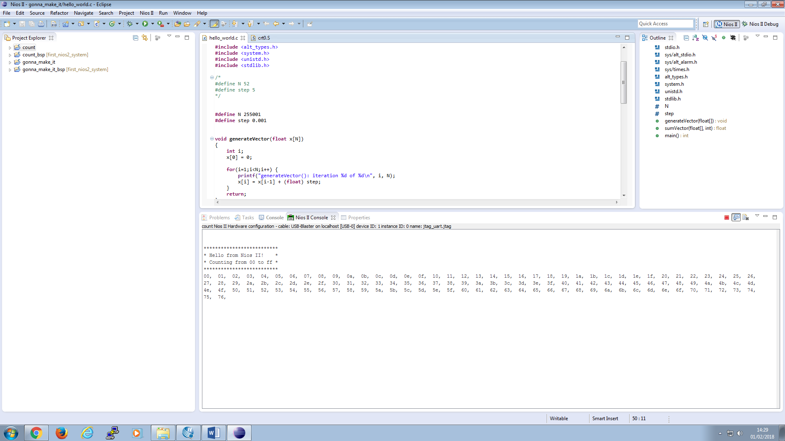

|  |  |  |
| --- | --- | --- |
| Case 1 | time elapsed: 3 ticks  Result (divided by 1014) = 1117 | Info: (task_3.elf) 38 KBytes program size (code + initialized data).  Info: 8152 KBytes free for stack + heap. |
| Case 2 | time elapsed: 142 ticks  Result (divided by 1014) = 54326 | Info: (task_3.elf) 38 KBytes program size (code + initialized data).  Info: 8152 KBytes free for stack + heap. |
| Case 3 | time elapsed: 14379 ticks  Result (divided by 1024) = 5449760 | Info: (task_3.elf) 39 KBytes program size (code + initialized data).  Info: 8152 KBytes free for stack + heap. |

|  |  |  |
| --- | --- | --- |
| Cache size (task 3) | Runtime | resources |
| 512 | Gen: 4185  Sum: 19025 |  |
| 1K | Sum: 17237  Gen:4040 |  |
| 2K | Sum: 14109  Gen: 2768 |  |
| 4K | Sum: 11745  Gen: 2761 |  |
| 8K | time elapsed(gen): 2745 ticks  time starts now...done.  time elapsed(sum): 11616 ticks  gen: 2745  time: 11616 |  |
| 16K | time elapsed(gen): 2745 ticks  time starts now...done.  time elapsed(sum): 11615 ticks |  |
| 32K | time elapsed(gen): 2745 ticks  time starts now...done.  time elapsed(sum): 11616 ticks |  |

128 byte onchip mem

Task 4

Testing new, more complex function

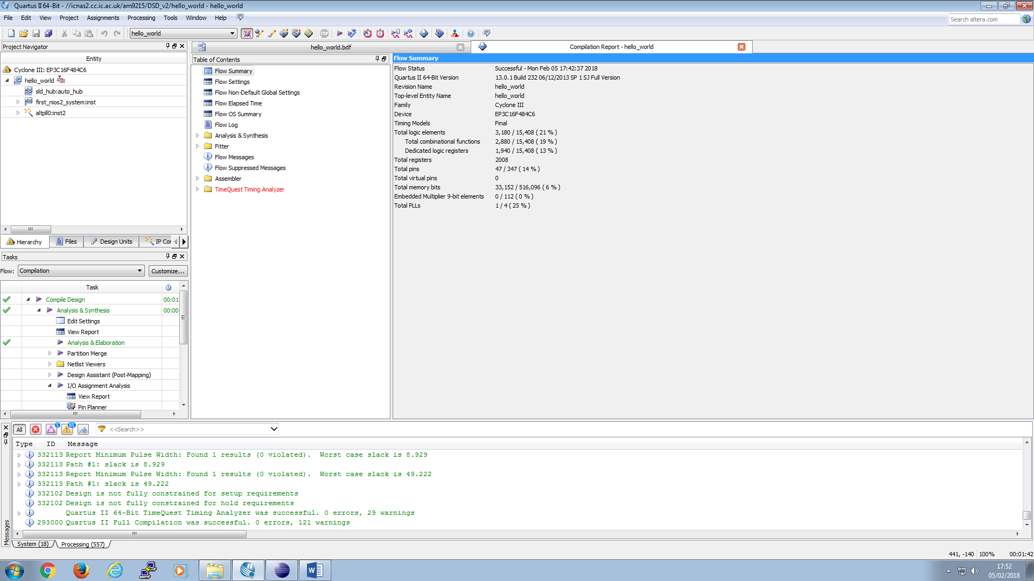

Info: (task_4_2.elf) 84 KBytes program size (code + initialized data).

Info: 8100 KBytes free for stack + heap.

Info: Creating task_4_2.objdump

With new bsp properties (no small library or drivers)

|  |  |  |  |
| --- | --- | --- | --- |
| New function, no cpu multiplier | 2K | 4K | 8K |
| Task 1 | Time: 85  Result: 57879.867188 | Time: 78  Result: 57879.867188 | Time: 72  Result: 57879.867188 |
| Task 2 | Time: 4183  Result: -76973.390625 | Time: 3835  Result: -76973.390625 | Time: 3546  Result: -76973.390625 |
| Task 3 | Time: 423710  Result: 37022484.0 | Time: 387025  Result: 37022484.0 | Time: 353957  Result: 37022484.0 |

(for new fancy function)

|  |  |  |  |  |  |
| --- | --- | --- | --- | --- | --- |
| With multiplier support  Info: (task_5.elf) 82 KBytes program size (code + initialized data).  Info: 8102 KBytes free for stack + heap.  Info: Creating task_5.objdump | 2K | 4K | 8K | 16K | 32K |
| Task 1 | Time: 33  Result: 57879.867188 | Time: 27  Result: 57879.867188 | Time: 21  Result: 57879.867188 | Time: 14  Result: 57879.867188 | Time: 13  Result: 57879.867188 |
| Task 2 | Time: 1574  Result: -76973.390625 | Time: 1321  Result: -76973.390625 | Time: 1029  Result: -76973.390625 | Time: 663  Result: -76973.390625 | Time: 639  Result: -76973.390625 |
| Task 3 | Time: 162813  Result: 37022484.0 | Time: 133896  Result: 37022484.0 | Time: 103790  Result: 37022484.0 | Time: 66896  Result: 37022484.0 | Time: 63839  Result: 37022484.0 |

TODO: do for LE multipliers

|  |  |  |  |  |
| --- | --- | --- | --- | --- |
| Logic Multipliers  Info: (task_5.elf) 82 KBytes program size (code + initialized data).  Info: 8102 KBytes free for stack + heap.  Info: Creating task_5.objdump | 2K | 4K | 8K | 16K |
| Task 1 | Time: 34  Result: 57879.867188 | Time: 29  Result: 57879.867188 | Time: 23  Result: 57879.867188 | Time: 21  Result: 57879.867188 |
| Task 2 | Time: 1643  Result: -76973.390625 | Time: 1393  Result: -76973.390625 | Time: 1102  Result: -76973.390625 | Time: 1021  Result: -76973.390625 |
| Task 3 | Time: 169510  Result: 37022484.0 | Time: 141075  Result: 37022484.0 | Time: 111171  Result: 37022484.0 | Time: 103557  Result: 37022484.0 |